Can a face mask protect against the Coronavirus?

A computational-fluid-dynamics study.

Group 06

Su Hao Peng, Ye JiaYing, Toh Wei Wen, Ryan Tan Rui Yang, Jevan Goh (N.B.: the first author is the person who did the most work; the second author is the one who did the second-most work; and so forth…)

**Abstract**

With the spread of the Coronavirus, the had been implementation of the wearing of face mask as a preventive measure. The purpose of this report was to determine the effectiveness of face mask in protection against the Coronavirus. Transmission of coronavirus can occur through (i) talking, (ii) coughing and (iii) sneezing. To test the effectiveness of face mask, computational fluid dynamics (CFD) simulations were conducted for the three cases in a design of face mask with the aim of reduction in outlet velocity. Subsequently, comparisons between the CFD simulations for the three cases with and without face mask in an empty room were carried out. The results obtained showed that

<https://libguides.usc.edu/writingguide/introduction>

**Keywords:** Face mask, Coronavirus, flow velocity

**Introduction**

The purpose of this report is to evaluate the ability of a face mask in protecting its user and those in his vicinity against the coronavirus disease (COVID-19). The purpose of this report also includes reviewing existing research papers and value-adding to them with the application of Computational Fluid Dynamics (CFD) simulations. The programme used for the simulations is SIMSCALE[1].

The World Health Organisation (WHO) has advised governments to encourage their citizens to wear face masks in public [1]. In response, many governments, such as the Singapore [2] and Spanish [3] governments, have made it mandatory for their populace to wear face masks in public. Face masks filter out air particles and may protect others by reducing exposure to the saliva and respiratory secretions of the user [4].

Although many studies on the use of face mask in protecting people against COVID-19 have been done, little research made use of CFD simulations to evaluate its effectiveness.

* Rise of CFD
* How did CFD aid in fluid applications
* Report studied use of CFD in understanding protection against covid

**Literature Review**

Currently, there is ample evidence that the use of face masks is effective in reducing the spread of COVID-19 virus. Face masks are widely used globally as it has been proven to decrease the effective transmission rate within the mask-wearing-population. Statistics show that an adoption of the mask among 80% of the population could reduce the peak death rate by up to 45% of the predicted rate in New York City [5]. The effectiveness of the use of face masks has also been discussed by the Health Affairs[2]. The paper found that through the mask mandate issued by the local authority, the daily infection rate in 15 US states slowed down by 2% after 3 weeks [7].

Face masks offer two modes of protection: personal protection and source control. Masks achieve personal protection by preventing infectious droplets from entering the user’s respiratory system. When an infected person exhales air, infectious agents present in the exhaled air come into contact with the surrounding air, generating infectious aerosols [8]. If a person were to be in close contact with an infected other, transmission of infectious droplets could occur, causing the spread of the virus. The use of face masks protects one against infectious diseases by blocking off the transmission route of potentially infectious respiratory droplets, so that pathogens are prevented from entering his respiratory tract [9]. Currently, COVID-19 virus is mainly transmitted through respiratory droplets at close contact. However, airborne transmission of the virus can still occur under special circumstances. These circumstances include being in an enclosed area with an infectious person at the same time or shortly after an infectious person has left the area, having prolonged exposure to virus carrier particles and insufficient ventilation [10].

However, when attempting to implement source control, face masks are limited in guarding the user against finer particles. As the particle size decreases in diameter, the penetration increases — reaching 80 to 100 percent for particles ranging from 0.2 to 0.5 µm [11]. These escaped particles are spread through air carriage, and the particles’ transmitted distance is directly impacted by the velocity of air leaving the mask. In this aspect, masks are not effective in preventing the transmission of virus particles ranging from 0.2 to 0.5 µm.

In summary, the effectiveness of face masks has been shown and much research has been done to prove the blockage of droplets transmission route with the use of face masks. However, there are limited studies on the exit velocity of fine droplet particles. Thus, this study will further investigate this approach through CFD simulations of effective spread of Coronavirus through air.

**Materials and Methods**

Material

Our choice of CFD software, SIMSCALE, does not simulate the permeability of the material. Hence it is not possible to simulate or estimate the volume of air passing through the material. To simplify simulation, we are assuming walls are non-permeable, and all the fluids will not pass through the mask, rather, they travel along the boundary walls without passing through.

Simplification of Model - 2D

We have simplified the simulation of our mask to a 2D model. After air leaves the nose and/or mouth, it travels along the plane of the mask; this is comparable to a  
2-dimensional flow, with a centre inlet. Thus, a plane solution offers sufficient similarity to a 3D model.

Since in reality the contact spacing between face and mask is very small, we will be modelling our structure within the mask, which will slow down the fluid velocity, to be sandwiched between 2 closely spaced, neighbouring walls (~2 mm). One wall represents the face surface and another represents the surface of the ‘impermeable’ mask.

Design

Following the 8 steps for generating a CFD simulation, a computational domain was first generated. Using Onshape[3], a rectangular box of length 190 mm, height 130 mm and thickness 9 mm, with a circular cylinder of diameter 30 mm and thickness 9 mm at the center of the box was constructed.

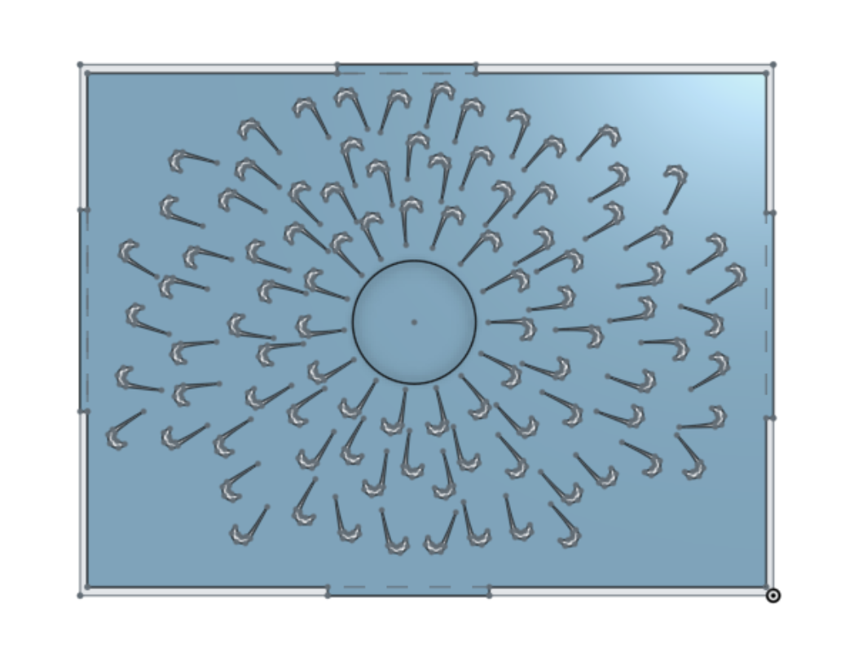

Figure 1: Design of face mask

As seen in Figure 1, the internal layer between the two surfaces of the face mask has multiple Tesla Valve structures that extend radially from the centre inlet to the four outlets at the borders of the face mask.

With reference to the Tesla Valve structure, the air flowing into the mask will not be hindered but the air flowing out from the mask will face resistance as the stream is broken up and diverted into circular paths that will interfere with each other, resisting flow in that direction [13] and thus reducing the velocity of the air flowing out.

Parameters

Next, specific physical parameters of the fluid system were set, such that the incompressible air flow is laminar and steady. The software used default density and kinematic viscosity values of 1.196 kg/m3 and 1.57 x 10-5 m2/s respectively for air.

The Mode

The different flow velocities of air when one is talking, coughing and sneezing are obtained and recorded in Table 1 for the simulations [14,15,16].

Table 1: Flow velocities for the different mode of air propagation

|  |  |
| --- | --- |
| Mode of Propagation | Velocity (m/s) |
| Talking | 3.1 |
| Coughing | 11.7 |
| Sneezing | 15 |

Boundary and initial conditions were then set. On the surface of the center circular cylinder, a velocity inlet, of values that vary with the mode of air propagation (refer to Table 1), in the negative z-direction was fixed. Pressure outlets of 0 Pa were also assigned at each of the four edges of the rectangular box. Lastly, observations were noted down for the simulations using the different velocity inlet values for talking, coughing and sneezing, with very coarse mesh.

**Results and Discussion**

Using very coarse mesh, a cutting plane normal to the x-axis was created on the CFD simulations for the face mask with various velocity inlet for the scenarios of talking, coughing and sneezing (Figures 2, 3 and 4 respectively).

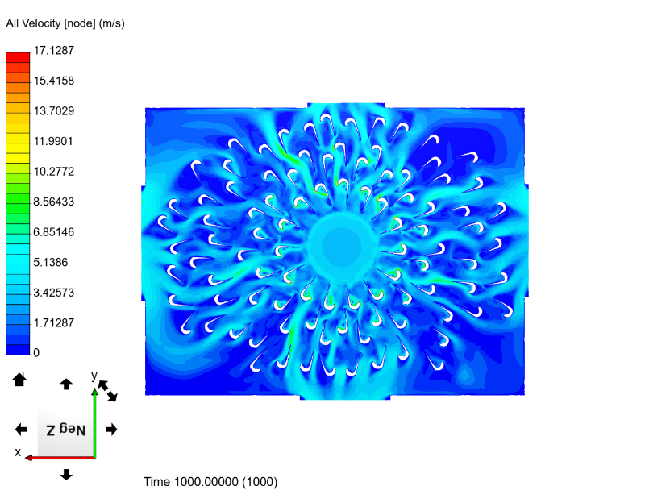

Figure 2: Flow of air in the face mask when talking

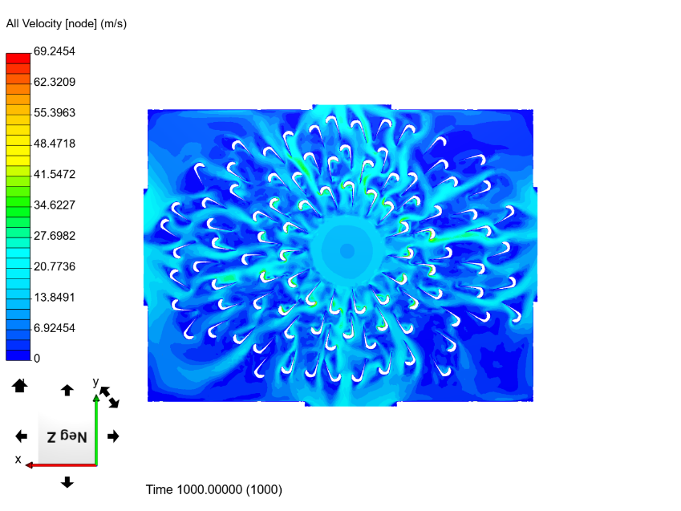

Figure 3: Flow of air in the face mask when coughing

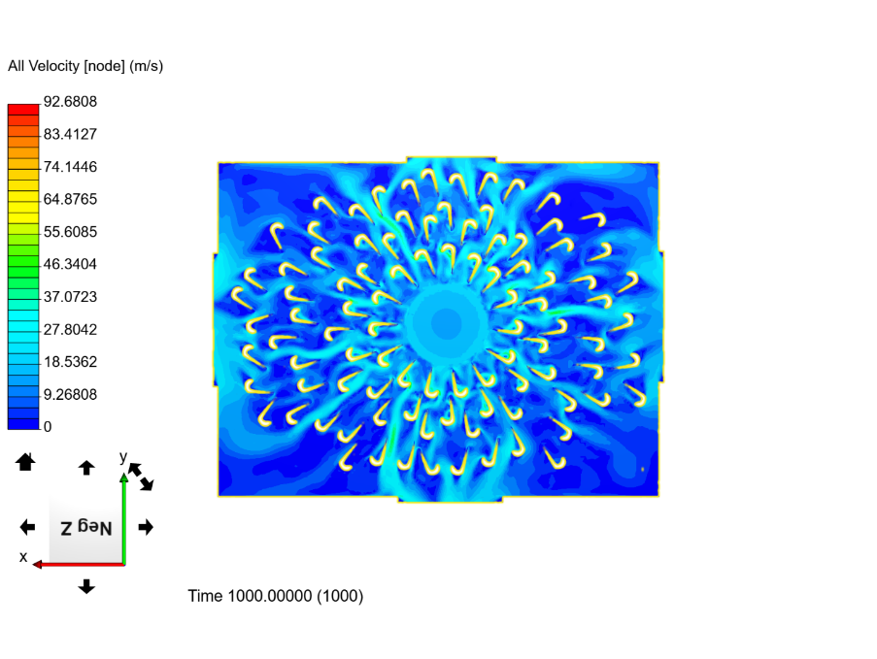Figure **4**: Flow of air in the face mask when coughing

With reference to Figure 2 to 4, the average outlet flow velocities from the face mask for the three different modes of propagation is obtained.

Table 2: Average outlet velocities for the different mode of air propagation

|  |  |
| --- | --- |
| Mode of Propagation | Average Outlet Velocity (m/s) |
| Talking | 2.27 |
| Coughing | 8.96 |
| Sneezing | 11.4 |

Using Tables 1 & 2, simulations of various inlet flow velocities with and without a face mask in an empty room are performed.

|  |  |  |
| --- | --- | --- |
|  | Without Mask | With Mask |
| Talking | Figure 5: Fluid velocity of 0.35m/s at 10m | Figure 6: Fluid velocity of 0.28m/s at 10m |
| Coughing | Figure 7: Fluid velocity of 1.44m/s at 10m | Figure 8: Fluid velocity of 1.17m/s at 10m |
| Sneezing | Figure 9: Fluid velocity of 2.0m/s at 10m | Figure 10: Fluid velocity of 1.44m/s at 10m |

Using the fluid velocity found for talking, coughing and sneezing (without face mask) as the inlet velocity, we obtained the results as shown in Figure 5, 7 and 9. The results in Figures 6, 8 and 10 were achieved using the average velocity found from Figures 2, 3 and 4 as the inlet velocity. The models are simulated in a 10m by 10m room. Figures 5, 7 and 9 shows the results for the fluid velocity without face mask while figures 6, 8 and 10 shows the results for the fluid with face mask.

Generally, fluid velocity decreased across the room in all cases; with mask and without mask. However, the decrease in fluid velocity is more significant for the cases with the mask as compared to the cases without mask. For talking, the fluid velocity at 10 metres away from the inlet (at the end of the room) is 0.28 m/s with the presence of mask, which is lower than the velocity of 0.35 m/s without mask. This trend occurs for all other modes of propagation; the velocity decreased from 1.44 m/s without mask to 1.17 m/s with mask for coughing; and decreased from 2.00 m/s without mask to 1.44 m/s with mask.

It is also observed from the CFD that for velocity with mask, the air stream shows a narrower spread in the cylindrical direction.

Coupled both observations, is can be inferred that particles from the nozzle will be less wide-spread compared to without mask. With a smaller velocity at 10 metres away from nozzle, lesser particles are likely to travel to 10 metres away from nozzle. Particle fall out is more likely to happen along the way with a lower velocity, since a lower velocity infers that the particle will be suspended in the air for a longer period of time before it reaches 10 m away. A longer period of suspension will allow a longer time for the particle to settle to the ground and prevent it from travelling far. Hence fewer particle will be found at 10 m away with a lower velocity.

Since lesser particles can be found at 10 m away, it can be inferred that the probability of COVID contraction will be reduced. Hence, wearing mask will prove to be beneficial in reducing COVID spreading as it reduces the effective air velocity for sneezing, coughing and talking.

Limitations

Although xyz, there are several limitations to our study. Firstly, since the time taken for the face mask’s CFD simulations using the very coarse mesh took approximately 6 hours to be completed, only the very coarse mesh was used for the simulations to save time. Consequently, the results from the simulations in Figures 2 to 4 might not be as accurate as desired.

Secondly, to simplify the CFD simulations of our face mask, it is assumed that the flow into the mask is laminar and incompressible, and that air flows directly into the inlet of the mask. However, in reality, the particles that flow into face masks are not necessarily laminar and incompressible. Also, air flows into the face mask in all directions, instead of only through the centre of mask.

Lastly, although gravity and drag force are significant in real-life, all simulations were made with the assumption that there are no gravity and drag force acting on the flow particles. Unfortunately, this limitation cannot be corrected due to the lack of tools.

**Conclusions**

It is observed that face masks minimized the fall out distance of particles flowing through reducing the escape velocity of the particles. Hence, the use of face masks would protect others against COVID-19 and other infectious diseases.

Despite our extensive findings from the CFD simulations, more could be done to broaden our study. For instance, for more accurate and realistic values of the particles’ flow velocity through the face mask, finer meshes could be used for the face mask’s CFD simulations. Furthermore, this would ensure that any additional characteristic of the flow would be captured. Unfortunately, due to the complexity of the simulation, combined with the lack of time and computational resources, the simulations using finer meshes could not be run. Thus, if provided with the simulations done using finer meshes, a check for grid-independence could be done. Also, further simulations of the face mask using other flow conditions that consider turbulence and compressibility could be run.

**Acknowledgments**

This template was adopted from the Journal of Electrical Bioimpedance.

**References**

1. David S. Coronavirus: WHO advises to wear masks in public areas [Internet]. 2020 [cited 2020Oct30]. Available from: <https://www.bbc.com/news/health-52945210>.

1. Guidance for Use of Masks and Face Shields [Internet]. Ministry of Health. [cited 2020Oct30]. Available from: <https://www.moh.gov.sg/news-highlights/details/guidance-for-use-of-masks-and-face-shields>.
2. Face masks are now mandatory in Spain: What you need to know [Internet]. thelocal.es. 2020 [cited 2020Oct30]. Available from: <https://www.thelocal.es/20200519/what-you-need-to-know-about-spains-new-rule-to-make-face-masks-mandatory>.
3. Mayo Clinic Staff. COVID-19: How much protection do face masks offer? [Internet]. Mayo Clinic. Mayo Foundation for Medical Education and Research; 2020 [cited 2020Oct30]. Available from: <https://www.mayoclinic.org/diseases-conditions/coronavirus/in-depth/coronavirus-mask/art-20485449>.
4. Eikenberry SE, Mancuso M, Iboi E, Phan T, Eikenberry K, Kuang Y, et al. To mask or not to mask: Modeling the potential for face mask use by the general public to curtail the COVID-19 pandemic [Internet]. Infectious Disease Modelling. Elsevier; 2020 [cited 2020Oct30]. Available from: <https://www.sciencedirect.com/science/article/pii/S2468042720300117>.
5. *About Health Affairs* [Internet]. [cited 2020Nov6]. Available from: <https://www.healthaffairs.org/about>
6. Wei L, George L. W. *Community Use of Face Masks And COVID-19: Evidence From A Natural Experiment Of State Mandates In The US* [Internet]. Health Affairs. 2020 [cited 2020Nov6]. Available from: <https://www.healthaffairs.org/doi/10.1377/hlthaff.2020.00818>
7. Atkinson J, Chartier Y, Pessoa-Silva CL, et al., editors. Natural Ventilation for Infection Control in Health-Care Settings. Geneva: World Health Organization; 2009. Annex C, Respiratory droplets. Available from: <https://www.ncbi.nlm.nih.gov/books/NBK143281/>
8. Chen X, Ran L, Liu Q, Hu Q, Du X, Tan X. Hand Hygiene, Mask-Wearing Behaviors and Its Associated Factors during the COVID-19 Epidemic: A Cross Sectional Study among Primary School Students in Wuhan, China. International journal of environment research and public health, 17(8), 2893; 2020 [cited 2020Nov6]. Available from: <https://www.ncbi.nlm.nih.gov/pmc/articles/PMC7215913/>
9. Scientific Brief: SARS-CoV-2 and Potential Airborne Transmission [Internet]. Centers for Disease Control and Prevention. Centers for Disease Control and Prevention; 2020 [cited 2020Nov6]. Available from: <https://www.cdc.gov/coronavirus/2019-ncov/more/scientific-brief-sars-cov-2.html>
10. Lai A. C., Poon C. K., Cheung A. C. *Effectiveness of facemasks to reduce exposure hazards for airborne infections among general populations*. Journal of the Royal Society, Interface, 9(70), 938-948; 2019 [cited 2020Nov6]. Available from: <https://www.ncbi.nlm.nih.gov/pmc/articles/PMC3306645/>
11. Product Development Platform [Internet]. Onshape. [cited 2020Nov6]. Available from: https://www.onshape.com/en/
12. Brain B. Tesla’s one-wave valve is simply genius [Internet]. Reef Builders. 2013 [cited 2020Nov6]. Available from: <https://reefbuilders.com/2013/03/11/teslas-oneway-valve/>
13. 24-HOUR FORECAST [Internet]. Meteorological Service Singapore. 2020 [cited 2020Nov6]. Available from: <http://www.weather.gov.sg/home/>
14. Jitendra K. G., Hsin Lin C., Qingyan C. Characterizing Exhaled Airflow from Breathing and Talking. [cited 2020Nov6]. Available from: <http://edge.rit.edu/content/P13051/public/Research%20Notes/Characterizing%20Exhaled%20Airflow%20from%20Breathing.pdf>
15. Mortazavy Beni H, Hassani K, Khorramymehr S. In silico investigation of sneezing in a full real human upper airway using computational fluid dynamics method. Computer Methods and Programs in Biomedicine, 177, 203-209; 2019 [cited 2020Nov6]. Available from: <https://europepmc.org/article/med/31319949>

**Appendix A. Distribution of work**

Summarize what the different authors did for the project. For the sake of brevity, you can introduce abbreviations for the names of the authors: e.g., Erik Birgersson (EB) prepared this template; EB used the original template by the Journal of Electrical Bioimpedance for this purpose.

**Abstract**Use this document as a template (do not change the formatting).

See e.g. the following link for more information on writing a research paper:

<https://libguides.usc.edu/writingguide/introduction>

**Keywords:** …

**Introduction**

The paper size is A4 (21 × 29.7 cm). The margins are set to 2.5 cm for the top and 1.5 cm for the sides and bottom. The main body of the manuscript is in two columns separated by a 1 cm with justified text. The line spacing is 1.1, and the references list has 3 pt. spacing between each reference. The page limit is set to 10 pages.

Body text is Calibri 10 pt. Level 1 headings are in bold and level 2 headings are in italic.

Figures may be in color or black and white and must be of such quality that they produce clear and sharp printouts on an ordinary (color) laser printer.

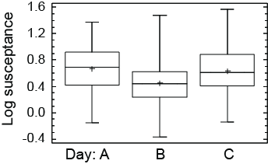

**Figure 1.** Box-plot showing median value (line), mean value (cross), middle 50% (box) and smallest and largest point within 1.5 interquartiles from the box (whiskers) of all measurements on days A, B and C.

The introduction section of your paper should include the necessary background information for your project and its components.

Upload as a PDF file, Project#.pdf, to IVLE; here # denotes the group number.

**Literature Review**

This part of the literature

**Materials and methods**

Enough information should be given so that other researchers can reproduce your study. Can you verify your model? Here you can include your theoretical understanding of fluid flow.

**Results and discussion**

Present and discuss all your findings. All figures should be numbered consecutively with the figure legend indented 0.5 cm on each side. See Fig. 1 for an example. The maximum number of figures is 10 in total for the entire article. Here you can include explanations as well as descriptions of the observed fluid flow etc.

**Conclusions**

Summarize your findings and discuss how your current study could be extended further.

**Acknowledgments**

This template was adopted from the Journal of Electrical Bioimpedance.

*Reference style*

We use the Vancouver style of references with numbers in square brackets in the text and a numbered list in the Reference section [1]. *Remove this subsection from your own article.*

**References**

1. National Institute of Health [Internet]. International Committee of Medical Journal Editors Uniform Requirements for Manuscripts Submitted to Biomedical Journals. [Updated 2009 Aug 28; cited 2009 Oct 6]. Available from:  
   http://www.nlm.nih.gov/bsd/uniform_requirements.html .
2. Halpern SD, Ubel PA, Caplan AL. Solid-organ transplantation in HIV-infected patients. N Engl J Med. 2002;347:284-7.
3. Rose ME, Huerbin MB, Melick J, Marion DW, Palmer AM, Schiding JK, et al. Regulation of interstitial excitatory amino acid concentrations after cortical contusion injury. Brain Res. 2002;935(1-2):40-6.
4. Murray PR, Rosenthal KS, Kobayashi GS, Pfaller MA. Medical microbiology. 4th ed. St. Louis: Mosby; 2002.
5. Meltzer PS, Kallioniemi A, Trent JM. Chromosome alterations in human solid tumors. In: Vogelstein B, Kinzler KW, editors. The genetic basis of human cancer. New York: McGraw-Hill; 2002. p. 93-113.

**Appendix A. Distribution of work**

Summarize what the different authors did for the project. For the sake of brevity, you can introduce abbreviations for the names of the authors: e.g., Erik Birgersson (EB) prepared this template; EB used the original template by the Journal of Electrical Bioimpedance for this purpose.

1. SIMSCALE is
2. Health Affairs is the leading journal of health policy thought and research [6].
3. Onshape is a product development platform that unites computer-aided design, data management collaboration tools and real-time analytics [12].